**US economy grew at 2.6% rate in fourth quarter**

[*U.S. Economy*](https://www.foxbusiness.com/category/us-economy)[*FOX Business*](http://www.foxbusiness.com/index.html) - [Megan Henney](https://www.foxbusiness.com/person/h/megan-henney) - February 28, 2019

The [**U.S. economyOpens a New Window.**](https://www.foxbusiness.com/category/us-economy) grew by a rate of 2.6 percent this winter, beating analysts' estimates of 2.3 percent thanks to solid consumer and business spending.

It also bested **[GDPNowOpens a New Window.](https://www.foxbusiness.com/economy/fourth-quarter-gdp-to-be-released-on-thursday-what-to-expect" \t "_blank)**, a real-time tracker monitored by the Federal Reserve Bank of Atlanta, which lowered its estimate to 1.8 percent earlier this week, largely because of a grim outlook for retail sales, which took a hit, in part, due to the shutdown.

“Overall, with expectations fairly low going into this report, this was a positive surprise that should reinforce the overall health of the U.S. economy for investors,” said Charlie Ripley, senior investment strategist for Alliance Investment Management.

Release of the fourth-quarter GDP by the Bureau of Economic Analysis (BEA) was delayed by almost one month as a result of the 35-day partial government shutdown, the longest in U.S. history.

Expert Analyst, Alex Green, Believes This Obscure Stock Could Fully Fund Your Retirement Starting Today

In 2018, the GDP increased by an estimated 2.9 percent (compared to 2.2 percent in 2017), narrowly missing the Trump administration's goal of 3 percent growth for the year. That’s essentially the same annual growth as in 2015, which was the fastest pace since 2005.

"For the full year, growth was impressive, but the outlook for 2019 is expected to be more muted between fading global prospects, less lift from the tax cut and the clouds surrounding Brexit and U.S.-China trade,” said Mark Hamrick, the chief economist for Bankrate.com.

White House officials also applauded the number. Commerce Secretary Wilbur Ross said the GDP  -- which he said was buoyed by the 2017 Tax Cuts and Jobs Act -- “beat expectations comfortably.”

“President Trump has unleashed American growth at a pace the experts thought was not possible, approaching 3 percent GDP growth in 2018,” he said in a statement.

In the middle of February, U.S. retail sales recorded their biggest drop in more than nine years, spurring fears about an economic slowdown and a drop in consumer spending at the end of 2018. According to the Commerce Department, retail sales fell by 1.2 percent, the largest decline since September 2009, when the U.S. was still recovering from the Great Recession.

The BEA generally provides three estimates of the GDP for each quarter; however, they will only provide two readings this quarter. The final reading remains on track for March 28.

In the July-September period, the U.S. economy grew by 3.4 percent.

<https://www.foxbusiness.com/economy/us-economy-grew-at-2-6-percent-rate-in-fourth-quarter>

**GDP Shows U.S. Economy Is Steadier Than Thought**

*Bloomberg* - [Katia Dmitrieva](https://www.bloomberg.com/authors/AQ1oGARzwno/katia-dmitrieva), [Matthew Boesler](https://www.bloomberg.com/authors/AR2mfz_VWJM/matthew-boesler), and [Steve Matthews](https://www.bloomberg.com/authors/ABoOamiR284/steve-matthews) - February 28, 2019

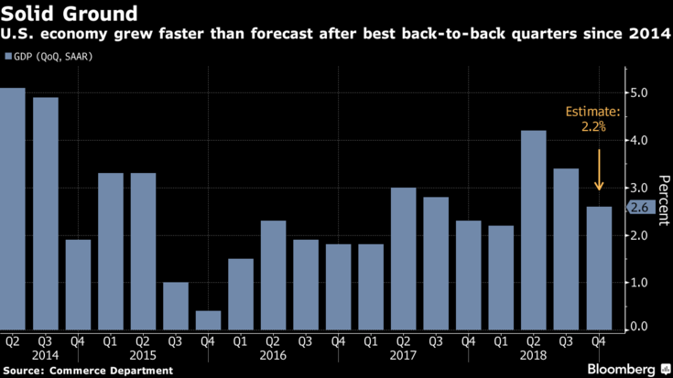The U.S. economy was steadier than thought at the end of last year, but it’s probably too soon to give it a clean bill of health for 2019.

That’s the main takeaway from the shutdown-delayed report Thursday on fourth-quarter gross domestic product, which cooled by [less than expected](https://www.bloomberg.com/news/articles/2019-02-28/u-s-gdp-grows-above-forecast-2-6-as-business-spending-picks-up) to a 2.6 percent annualized gain thanks to surprisingly robust business investment and a stalwart consumer.

The figures sent Treasuries lower and the dollar higher, and the Federal Reserve’s patience on interest rates is likely to support growth in coming months. But the longest government shutdown in U.S. history is poised to dent first-quarter expansion, while slowing global growth, President Donald Trump’s trade war and the fading impact of fiscal stimulus together suggest the economy will have a harder time sustaining momentum.

The GDP report shows that “the economy is doing pretty well, but it doesn’t change any of the risks that the Fed has identified,” said Sarah House, senior economist at Wells Fargo & Co. “They will continue to be patient.’’

Fed Vice Chairman Richard Clarida echoed that sentiment, saying Thursday that the central bank can take its time with interest-rate moves and noting that measures of inflation expectations appear anchored at the low end of the range he considers in line with the Fed’s 2 percent goal. Investors expect the central bank to stay on hold for the year.

“A number of crosscurrents that are buffeting the economy bear careful scrutiny,” Clarida said.

Inflation remained muted in the GDP report, adding little urgency for resuming interest-rate hikes. The Fed’s preferred price index rose at a 1.5 percent annualized pace last quarter, below the central bank’s 2 percent goal. Excluding food and energy, the index rose 1.7 percent.

The report gave the White House an economic milestone to boast about, as the Republican-backed tax cuts helped bring full-year growth to 3.1 percent, just above Trump’s 3 percent goal. The expansion is poised to become the nation’s longest on record at midyear.

Some analysts are taking the GDP data with a grain of salt since they reflect a December retail-sales drop that contradicted strong reports from major companies, while weakness in a proxy for business-equipment spending may have wrong-footed economists.

“On the surface, these numbers are pretty good,” said Ward McCarthy, chief financial economist at Jefferies LLC. “But the degree of confidence you can have in all the economic data right now is not what we’re accustomed to and not what it should be.”

Consumption, which accounts for the majority of the economy, grew 2.8 percent, slightly below forecasts, while nonresidential business investment accelerated to a 6.2 percent gain on equipment, software and research spending. Government spending slowed, trade was a minor drag and inventories gave GDP a small boost.

A separate report Thursday from the Labor Department showed filings for unemployment benefits rose by more than expected last week to 225,000, though still near a five-decade low. Other data indicated consumer sentiment rose last week and was close to an 18-year high, while business in the Chicago region picked up in February, as a purchasing managers’ index jumping to the highest level since December 2017.

Stephen Stanley, chief economist at Amherst Pierpont Securities, said in a note that consumer spending should remain solid in 2019 and could be stronger than expected “given the overwhelmingly positive fundamentals for household finances.”

**Business Investment**

Thursday’s report showed the third-quarter slowdown in business spending may have been temporary. Nonresidential fixed investment contributed 0.82 percentage point to growth following 0.35 point in the third quarter. Business-equipment investment rose 6.7 percent and intellectual property spending jumped 13.1 percent.

Yet a question looming over the data is the sustainability of that boost to growth from business investment. Some of the numbers represent a “guesstimate” that’s subject to revision, and may not prove durable anyway, according to Paul Ashworth, chief U.S. economist at Capital Economics.

In addition, housing remained a weak spot last quarter, posting the fourth consecutive drag on GDP growth, with a contraction of 3.5 percent. At the same time, there are [signs of demand picking up](https://www.bloomberg.com/news/articles/2019-02-27/u-s-pending-home-sales-top-forecasts-as-mortgage-rates-decline) in early 2019 thanks to a drop in borrowing costs.

**What Our Economists Say...**

The economy appears to have dodged a bullet at year-end -- but the coast is not clear ... Relative to history, the inventory accumulation in the second half of 2018 is large and threatens to overshadow production schedules (and manufacturing-related employment) in the first half of this year. Analysts should carefully scrutinize industrial surveys, such as the manufacturing ISM, for signs of a production lull intended to work off inventory excess.

<https://www.bloomberg.com/news/articles/2019-02-28/gdp-shows-u-s-economy-steadier-than-thought-as-headwinds-gather>